# Angular Forms Exercise

## Create Register Form

### Problem 2.1 Create a model

First off we need a **register model** that we can **bind** from the form and **send** to the API. A user should have a **username**, **password**, **first name**, **last name**, **email** and **age**. Create the model inside the models folder in authentication. It should look like this (age is optional):

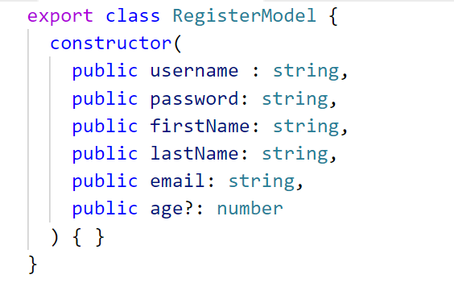

After we have created our model go to the register component typescript file and **initialize** the newly created model inside it.

### Problem 2.2 Create the template

To visualize a registration form copy the following **html** inside the template:

Our job is to add the necessary **directives**, **reference variables** and **attributes** in order to achieve a **two-way** data binding.

### Problem 2.3 Add validations

Your form should be able to **validate** all input fields and show an **error message** if the user entered incorrect information.

* Username must start with a **capital letter** and must contain **only** letters and digits.
* Password must contain **only letters and digits** and must be between **4** and **16** symbols.
* Both passwords must **match**.
* Names must contain **only letters** and start with a **capital letter**.
* There are various **email address patterns** in the internet. Find one and use it.
* Age is **optional** so it doesn’t matter.
* Disable the **register button** if something is invalid.

Attach a **submit function** to the form that we will implement later on.

### Problem 4.1 Create Authentication Service

After you have created a new app we need an authentication service to register, login, logout.

Create an **authentication service** inside the **authentication folder** (don’t forget to import the HttpClientModule and provide the service).

We need a function which retrieves **accurate http headers** according to which part of the application we want to reach.

If the user is logging in or registering we need a **Basic authentication**.

If the user is logging out or retrieving data that needs authentication we use **Kinvey authentication**.

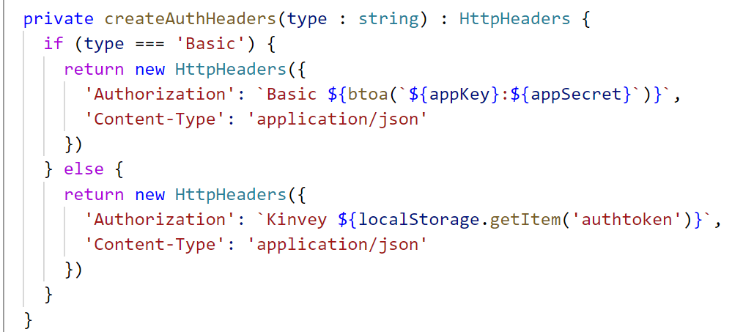

Logging in requires a **body**, **url** and **http headers**. The function should look like this:

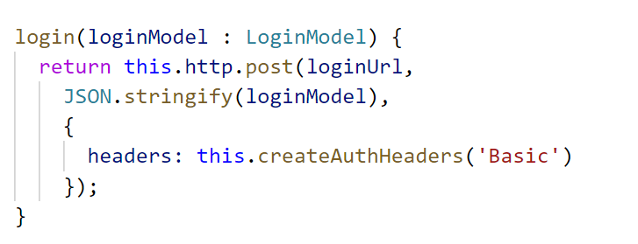

Registration is the **same** only this time we send the registration model and use the **register url**.

Logging out requires that you send an **empty body** and use **Kinvey** authentication.

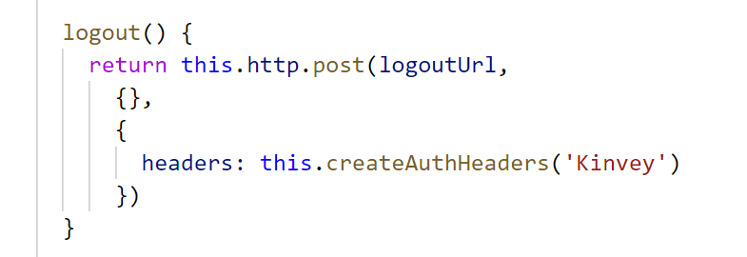

The last piece of the puzzle is to add a **current authtoken** field. Best to make it **private** and only be able to modify it inside the service (create a **getter** and **setter** for it). Also create a function which checks if the **user is logged in**. It compares the current authtoken to the one in local storage.

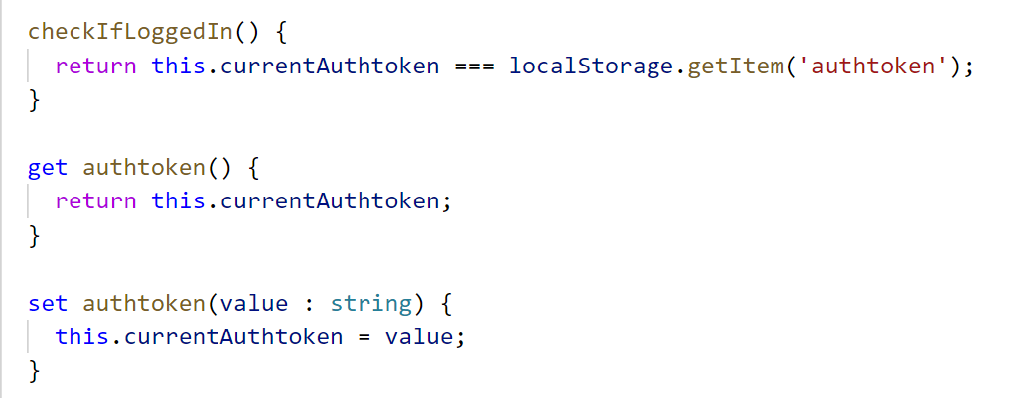

### Problem 4.2 Complete Register Component

Now that we have a service inject it into the register component and complete the **submit function**. A successful register should **redirect** to the **home page** (use Angular Router) and in case of an error show the **error description** in the html template.

### Problem 4.3 Complete Login Component

A successful login should **save the authtoken** inside **local storage** and **redirect** to the home page and in case of an error show the **error description** in the html template. This is how you set the authentication token:

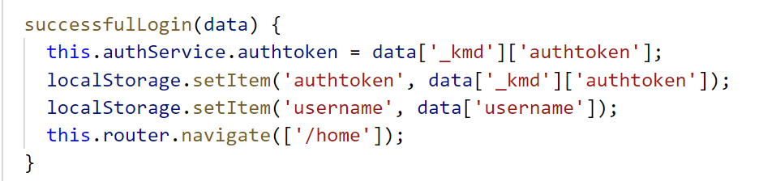

### Problem 4.5 Hide/Show navigation links

Think of a way to show **login/register** only for **anonymous** users and show **home/logout** only for **authenticated** users.

### Problem 4.6 Authentication Guards

Create a guard to allow access to the home page only for **authenticated users**.